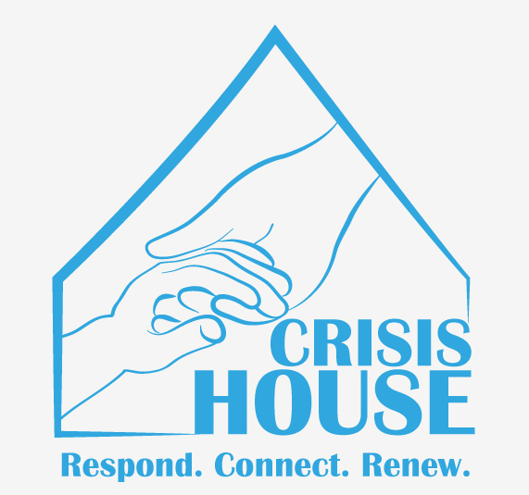
FOOD DRIVE
Support Crisis House
All food to be used for homeless families and individuals residing on the streets of our community.
Help by donating “Pop-Top” items. (Items that do not require heating.)
Our greatest need is for those items listed below…..

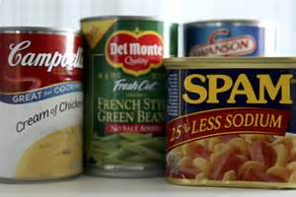
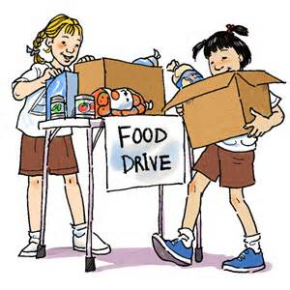
- Canned Vegetables/Beans - Canned Tuna & Chicken
- Canned Fruit - Macaroni & Cheese
- Canned Meats - Bottle Juices
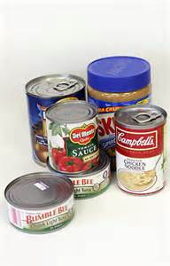
- Cereal/Oatmeal - Rice & Beans
- Pasta and Sauce - Peanut Butter/Jelly
- Canned Milk/Dry Milk - Canned Soup

Grocery Store Gift Cards for Milk, Dairy, Bread, and Produce are also welcome. We cannot accept outdated food.

Crisis House is a 501 (c)(3) non-profit charitable organization. Our Federal Tax ID # is 33-0217339. Donations are tax deductible.

